**Day 4 Lab Assignments**

**Please do these assignments:**

1. Make a search textbox, that when mouse is on it (on focus), it’s width increases gradually, and when mouse is out (on blur), it backs gradually to its original width
2. In the form assignment, add a dropdownlist to select gender (Male, female), and after select from it, write a text below it “Your Name: Mr. OR Ms.+ his entered name” based on his selected gender.
3. In the login form assignment (Assignment No.2), add “Show password” button besides the password input that changes the input type to “text” when checked, and changes it to “password” when unchecked. [use:document.getElementById("myInput").type].

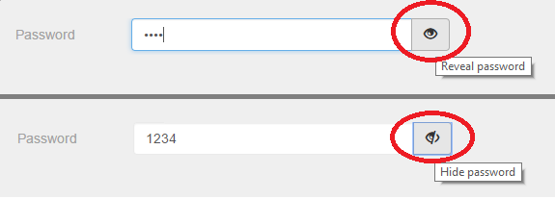

4-Make gallery Photo gallery with Next, Previous and Slideshow.

- Next goes to next pic and stops when reaching last image

- **Previous goes back to previous image and stops when reaching first image**

1. Let the delay between every to image lasts 2 seconds

-when click on any below circles go to image in this order



5- Apply different styles over a paragraph according to checked radio button. Implement the required functions in an external .js file to let TextStyle.html works properly

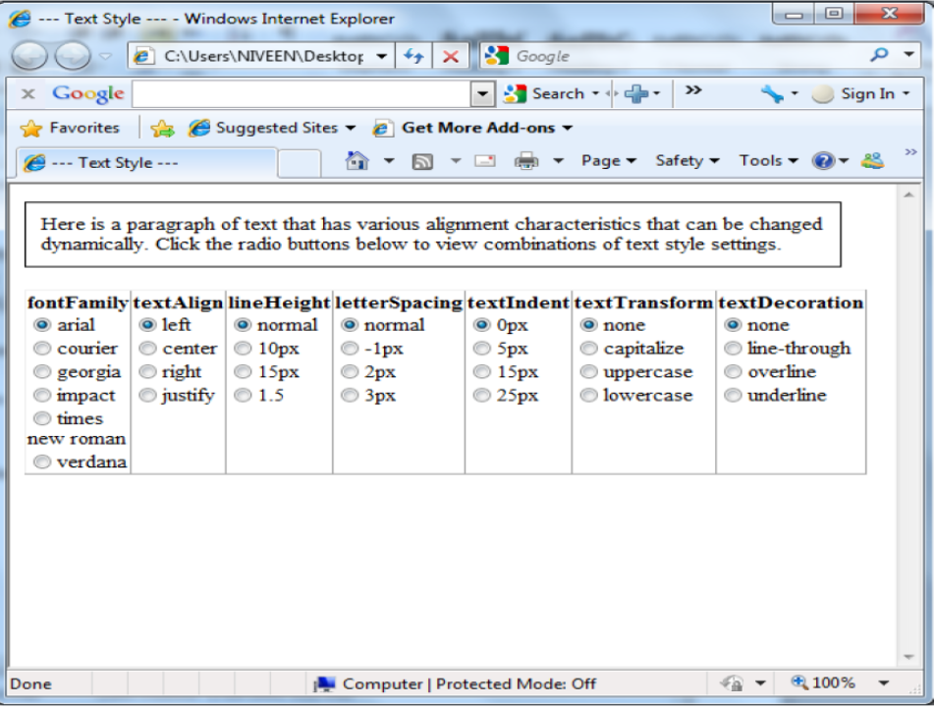

**Bonus assignments:**

1. Create an image like the following one, which has an image, image description text under the text and prev. and next buttons.  
    (Use array to store images name, and another to store images description) [You may use one associative array, instead of 2 arrays].
   1. Make the slide show start automatically when page loads.
   2. When the mouse is over an image show this image description below it and pause the slide show.
   3. When the mouse moves away from the image hide the description and resume the slide show.
   4. When the mouse is over next or Prev. buttons stop the slide show, and when the mouse moves away from them, resume the slide show.
   5. Make next button display the next image, and prev. button display the prev. image.

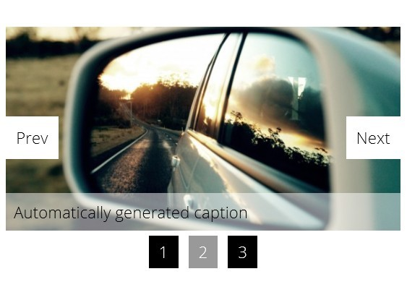

1. Make a div with width and height: 100px, and make a border and background color for it, and make an image that can be dragged and dropped on the div.
   1. Make the image back to its original position if dragged to any place rather than the div.
   2. Change the div background when the image is dropped over the div.
2. Complete stars assignment be complete 5 star rating control, that user can select rating from 1 to 5 stars (For example: if the user clicked on the the 3rd star all 3 stars should be filled and fixed, and when click on the 1st star one star only should be filled and fixed, and so on).
3. Make the label next to “I accept the terms and conditions” checkbox, as a link that opens new window contains terms and conditions.
4. Style the registration form like the following style:

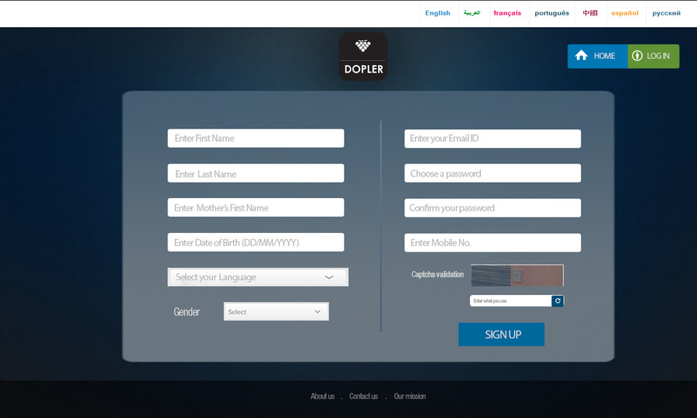

**<Script>document.write(“Thank YOU”) </Script>**